Customer roles

The customer roles in nopCommerce enable you to form groups of your web store users. You can create various groups, such as store admins, shoppers, [vendors](https://docs.nopcommerce.com/en/running-your-store/vendor-management.html), and others. You can also grant these groups certain rights, such as discounted pricing and other special statuses (such as tax exemption, free shipping, and more) using the [access control list](https://docs.nopcommerce.com/en/running-your-store/customer-management/access-control-list.html).

To manage customer roles, go to **Customers → Customer roles**. The *Customer roles* window will be displayed as follows:

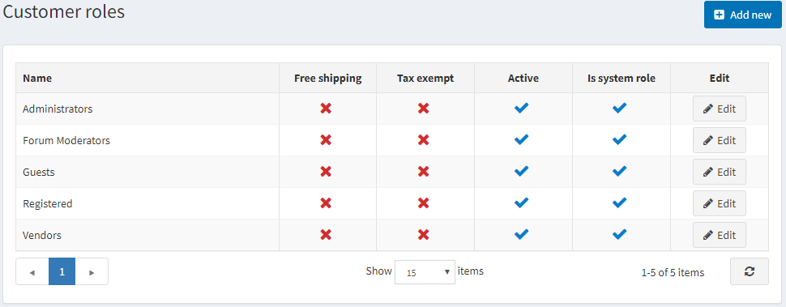

Click **Add new** to add a new customer role. The *Add a new customer role* window will be displayed:

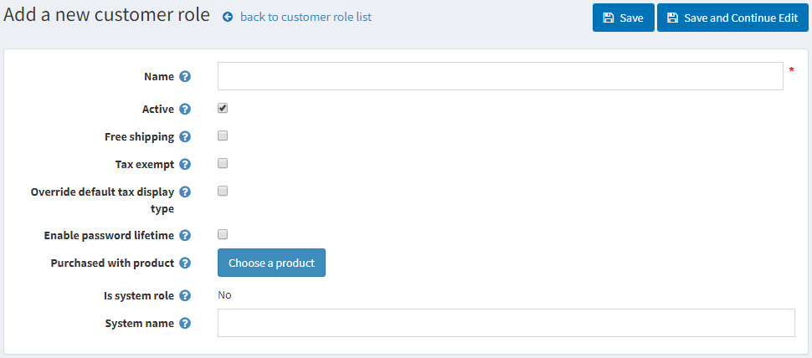

Define the following information:

* **Name** of the customer role.
* Select **Active** to make this role active.
* Select the **Free shipping** checkbox to enable customers with this role to get free shipping on their orders.
* Select the **Tax exempt** checkbox to enable customers with this role to make tax-free purchases.
* Select the **Override default tax display type** and select one of the tax types from the **Default tax display type** dropdown list:
  + *Including tax*
  + *Excluding tax*
* Select the **Enable password lifetime** to force customers to change their passwords after a specified time.
* **Purchased with product**. Click the **Choose product** button to choose a special product. A customer is added to this customer role once this product is purchased (paid).

**NOTE**

In the case of refund or order cancellation, you must manually remove a customer from this role.

* **Is system role**. This setting shows whether this role is used in the code. It is predefined and cannot be modified.
* **System name** of the customer role.

Click **Save**.